EXPERIMENT 11
DEPLOYMENT OF LOW-CODE APPLICATIONS
Gym Membership Enrollment & Front Desk Management

Parikshith P
Reg. No: 2116241401062
Computer Science and Business Systems
Rajalakshmi Engineering College, Chennai

Aim
To study the process of deploying low-code applications from the development environment to the production environment using Zoho Creator.

Procedure
- Start by opening an application in Zoho Creator.
- Identify the forms, reports, pages, and workflows used in the application.
- Test the application using sample records.
- Verify the form validations and workflow operations.
- Study the available application publishing and deployment options.
- Check user permissions and application accessibility.
- Document the deployment stages and verification process.
- Stop after completing the deployment study.

Introduction
Low-code application deployment is the process of making an application available to its intended users after development and testing. Zoho Creator provides visual development tools for creating forms, reports, dashboards, and automated workflows.
Deployment helps transform a developed application into a usable business solution. Before deployment, the developer must verify that the application works correctly and satisfies the required business operations.

Development and Testing
The development stage involves designing forms, configuring fields, creating reports, and implementing workflows. Sample records are entered to check whether data is stored and displayed correctly.
Testing is important because errors in field validation, calculations, or workflows may affect application performance. Developers should verify that mandatory fields work correctly, reports display accurate records, and automated actions execute as expected.

Deployment Process
The deployment process begins after the application has been tested. The developer reviews the application configuration, checks access permissions, and identifies the appropriate publishing options available in Zoho Creator.
After publishing or making the application accessible, the developer verifies that authorized users can access the required features. Any problems identified during verification should be corrected and tested again.

Maintenance
Deployment does not end when the application becomes available. Applications may require changes to business rules, fields, workflows, and reports. Updates should be tested before being introduced into regular use.
Maintenance also includes monitoring application performance, reviewing permissions, correcting errors, and ensuring that the application continues to meet business requirements.

Development and Production Comparison
Table 11.1. Development and Production Comparison
Parameter | Development Environment | Production Environment
Purpose | Used to design, build, and configure forms, reports, dashboards, and workflows. | Used for regular business operations by the intended users.
Testing | Application is tested with sample records; validations and workflows are verified. | Application is verified after publishing to confirm that authorized users can access it.
Users | Developers and testers. | Authorized end users such as gym staff.
Data | Sample or test records. | Actual business records, such as real member details.
Maintenance | Changes to fields, workflows, and reports are made and tested. | Performance, permissions, and errors are monitored; tested updates are introduced.

Practical Example
A gym membership application is developed using Zoho Creator. The developer creates a membership form, a report displaying registered members, and a dashboard showing membership details. After testing the application with sample records, it is published for authorized gym staff. The developer verifies that staff can register members and view the required reports.
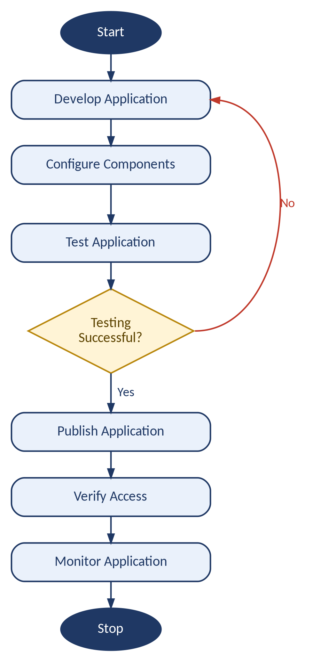
Figure 11.1. Application Deployment Flowchart

Result
Thus, the process of deploying low-code applications using Zoho Creator was studied.

References
- Zoho Creator Documentation: https://www.zoho.com/creator/help/
- Zoho Creator Help and Application Development Guides.

